Product Name:  Multifunction DC-DC Converter Step-up Step-down Dual Voltage Regulator Module Input 3-24V Output +-5V 6V 9V 10V 12V 15V 18V 24V

**Packing list:**

1 PCS 8W DC DC Step-up/Step-down Converter Positive and negative voltage Dual voltage Module

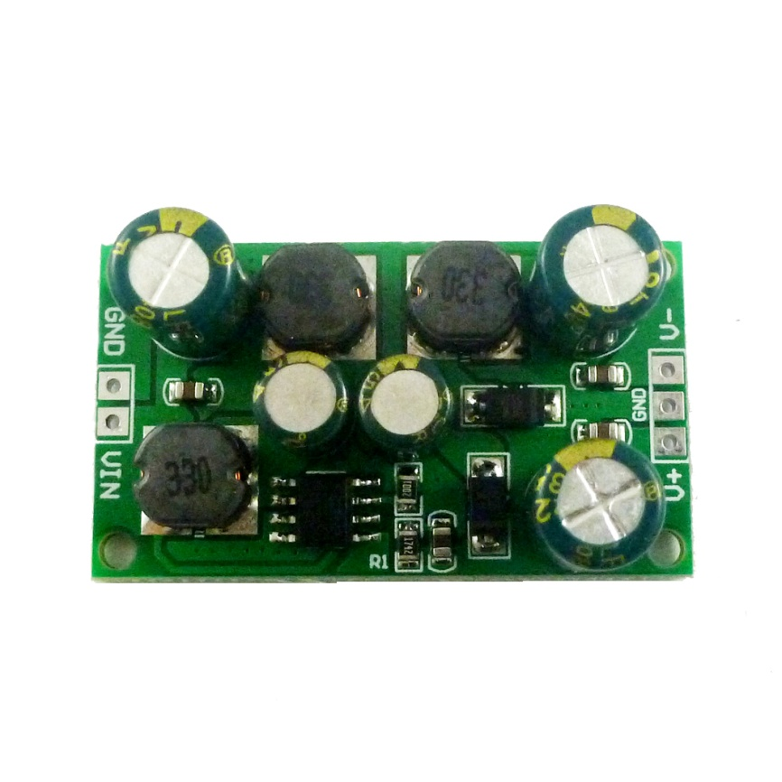

**Description:**

Input voltage 3~24V,output optional ±5V/±6V/±9V/±10V/±12V/±15V/±18V±24V

Maximum output power: 1-8W (For details, please see the description at the bottom or ask us for information.)

Conversion efficiency :71-90%

Quiescent current: 3-4mA  
Accuracy : Positive voltage ±3%,Negative voltage ±5

8W DC-DC Boost-Buck Converter working frequency 400KHZ.

Operating ambient temperature : -40~+85 Degrees Celsius

Size : 42 x 24 x 15mm

Weight :  10g

High efficiency up to 90%

Built in Frequency Compensation

Built in Soft-Start Function

Built in Thermal Shutdown Function

Built in Current Limit Function

Note:

1 In order to obtain a more stable voltage, it is recommended that the output is greater than 10MA

2  V- cannot be used alone, or no voltage output.But you can just use V+

**Applications**

ADC/DAC/Operational Amplifier Reference voltage

RS232 RS485 RS422 Bus

Audio equipment

Low power audio power supply

Car audio amplifier dual power board

LCD power supply

Instrumentation equipment

Instrumentation multimeter

Attention :

This is a DC-DC voltage converter module,Must be noted when using:

1 Input voltage can not be greater than the maximum input range  
2 Output power can not be greater than the maximum load for a long time  
3 Input power must be greater than the output power, because the power consumption of the module itself

Q & A:

Q1 : Why output voltage is less than the nominal voltage

A1: Input power supply power is too low.Test the input voltage with a multimeter,a t this time of the input voltage is very low

Q2 : Why is the negative voltage not output or the output too low?

A2 : The negative voltage cannot be used alone. When using a negative voltage, the same load must be connected at the positive voltage terminal.

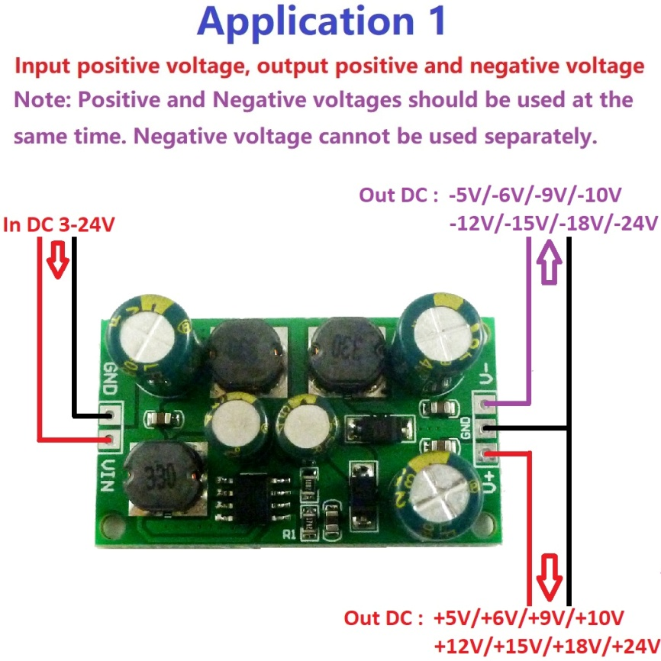

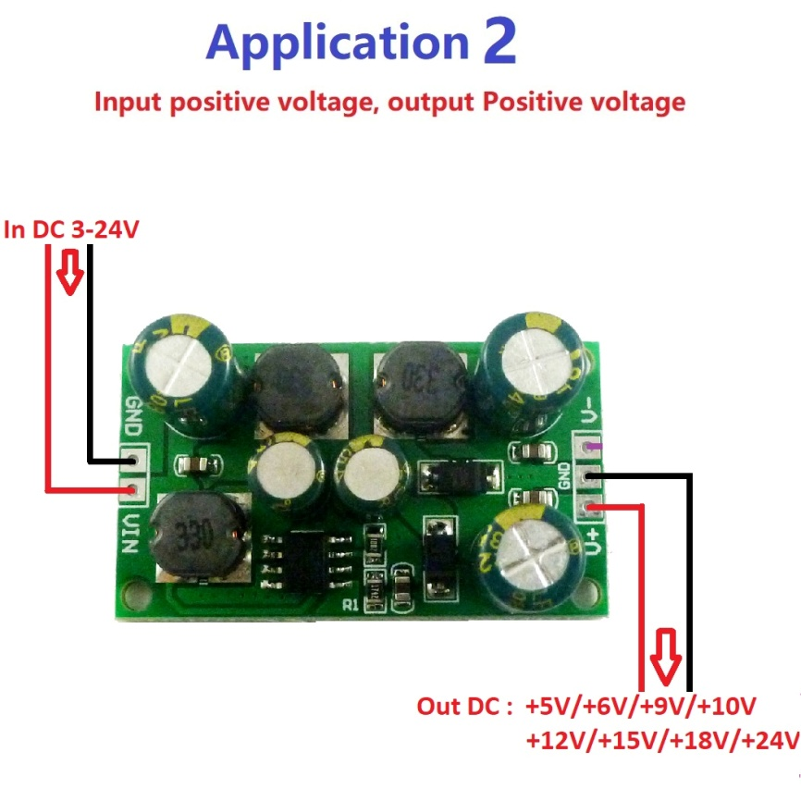

The maximum output power can reach 8W, but the maximum power will vary under different conditions. For details, please refer to the following table(10-80% of the maximum power is the most reliable):

Input DC 3-24V,Output ±5V  
Input voltage: 3V/3.3V/3.7V/5V/6V/9V/12V/15V/18V  
Maximum output current: 0.1-0.8A  
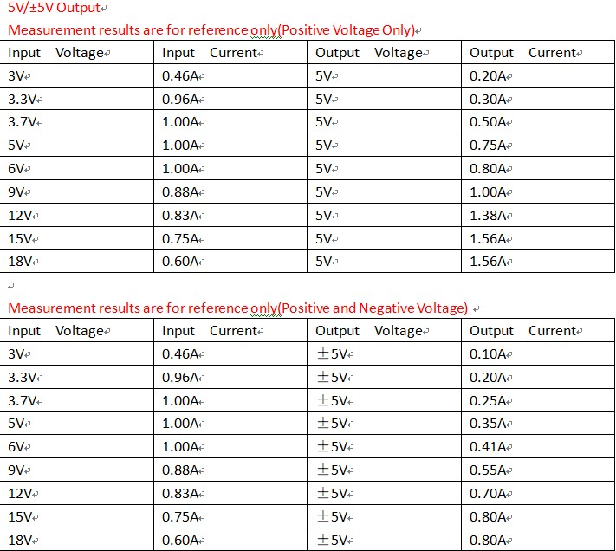  
Input DC 3-24V,Output ±6V  
Input voltage: 3V/3.3V/3.7V/5V/6V/9V/12V/15V/18V  
Maximum output current: 0.1-0.7A  
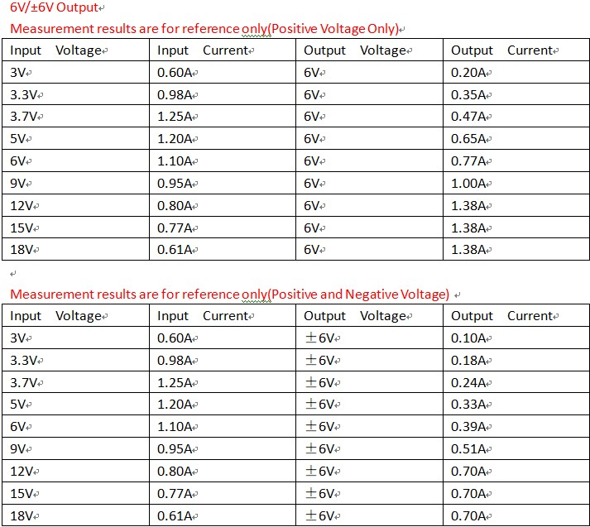  
  
Input DC 3-24V,Output ±9V  
Input voltage: 3V/3.3V/3.7V/5V/6V/9V/12V/15V/18V  
Maximum output current: 0.04-0.6A  
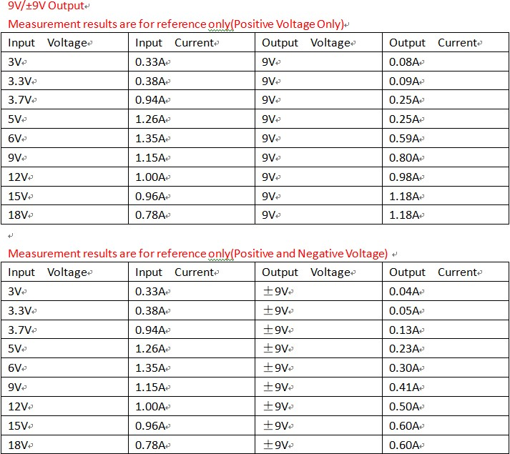  
Input DC 3-24V,Output ±10V  
Input voltage: 3V/3.3V/3.7V/5V/6V/9V/12V/15V/18V  
Maximum output current: 0.03-0.55A  
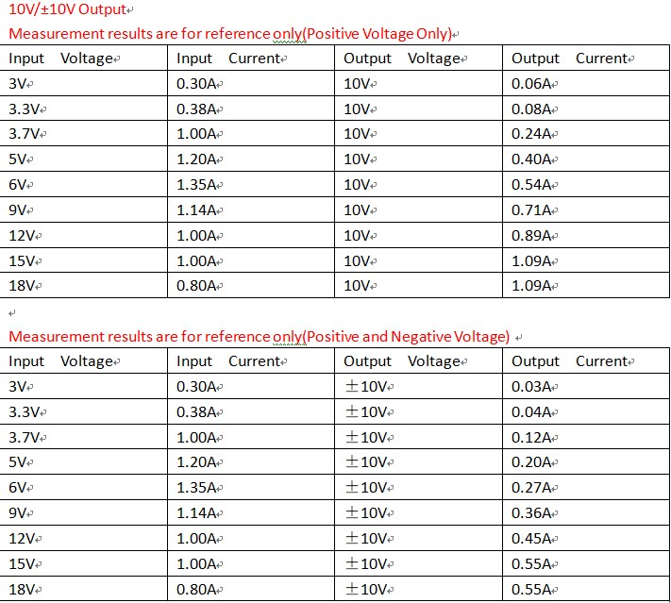  
  
Input DC 3-24V,Output ±12V  
Input voltage: 3V/3.3V/3.7V/5V/6V/9V/12V/15V/18V  
Maximum output current: 0.03-0.46A  
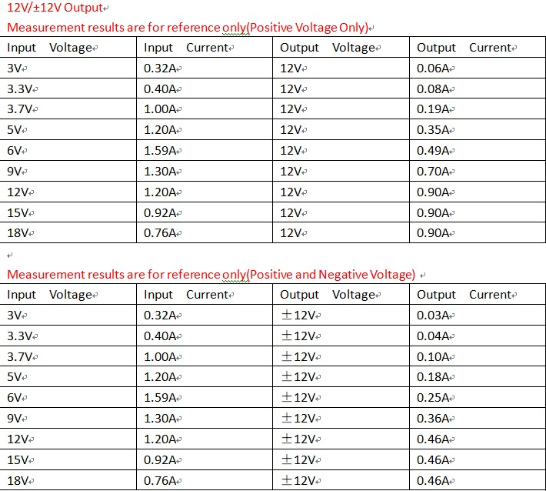  
Input DC 3.3-24V,Output ±15V  
Input voltage: 3.3V/3.7V/5V/6V/9V/12V/15V/18V  
Maximum output current: 0.03-0.41A  
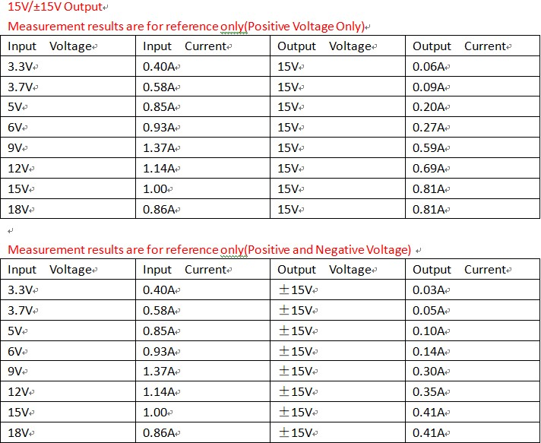  
Input DC 3.7-24V,Output ±18V  
Input voltage: 3.7V/5V/6V/9V/12V/15V/18V  
Maximum output current: 0.04-0.31A  
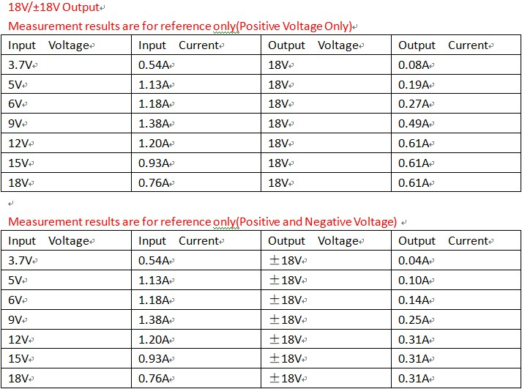  
Input DC 3.7-24V,Output ±24V  
Input voltage: 3.7V/5V/6V/9V/12V/15V/18V  
Maximum output current: 0.03-0.25A

