8-channel multifunction relay
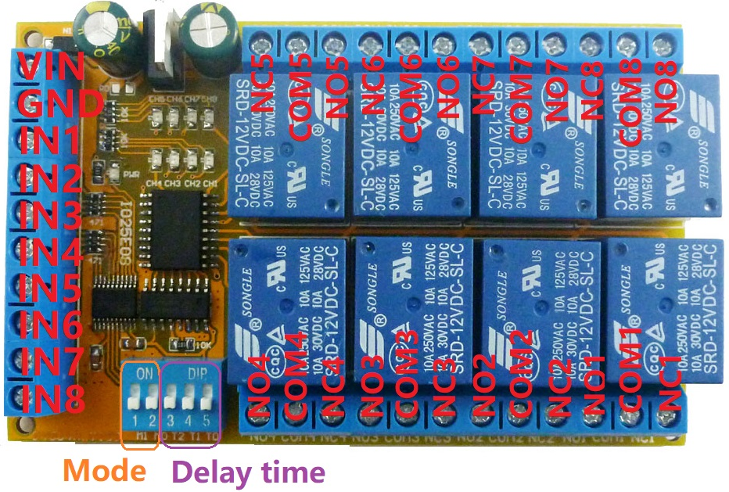
Product Specifications:
1 Operating voltage: DC 12V(DC 5V/ 24V Optional)
2 Operating Current(DC 12V) : Standby current 6MA, 1 relay open 35MA, 2 relays open 64MA, 3 relays open 92MA, 4 relays open 120MA, 5 relays open 148MA, 6 relays open 176MA, 7 relays open 204MA, 8 relays open 231MA
3 Size: 99 x 62 x 20 mm
4 Weight : 119g
5 Relay maximum load capacity: DC 1-110V/5A; AC 85-265V/6A

Product Features:
8 channel relay, each channel independently triggered independent delay, do not interfere with each other.
4 kinds of Functional mode: Delay/ Non-locking (Momentary ); Self-locking (Toggle); Inter-locking (Latch); Power sequencer(Relay sequence opens)
Low pulse trigger(Connect to the power supply GND via the trigger button or low level control via the MCU IO port)
The function mode and delay time are selected by the DIP switch.
Noun resolved:
NO : Relay normally open contact
COM : Relay common contact
NC : Relay normally closed contact
Relay open: COM connect NO.
Relay close: COM disconnect NO.

Typical applications:

Automotive electronics
AC DC Motor
Audio amplifier power supply.
Power Conditioner/Sequencer
LED
Smart Home
Emergency lighting
MCU development board
Toy car
UNO MEGA2560
PLC

how to use:
Select the desired function mode and delay time via the DIP switch on the board.
Note: Re-power up after changing the Dip switch
DIP switch  (Mode) | DIP switch  (Time) | M1 M0 T2 T1 T0 | Function | Description
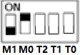 |  | 01XXX | Self-locking (Toggle) | Relay open->Relay close  Relay close-> Relay open
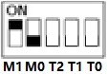 |  | 10XXX | Inter-locking (Latch) | The current channel relay open, the other channel relay close
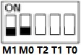  Delay/ Non-locking (Momentary ) | 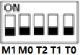 | 00000 | Non-locking  (Momentary )  Delay 0.5 Seconds | Relay open for 0.5 seconds
 | 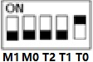 | 00001 | Delay 2 Seconds | Relay open for 2 seconds
 | 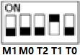 | 00010 | Delay 5 Seconds | Relay open for 5 seconds
 | 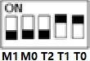 | 00011 | Delay 20 Seconds | Relay open for 20 seconds
 | 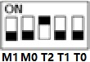 | 00100 | Delay 60 Seconds | Relay open for 60 seconds
 | 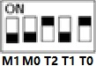 | 00101 | Delay  600 Seconds | Relay open for 600 seconds
 | 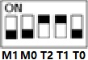 | 00110 | Delay  1800 Seconds | Relay open for 1800 seconds
 | 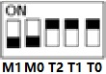 | 00111 | Delay  3600 Seconds | Relay open for 3600 seconds
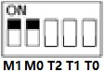  Power sequencer | 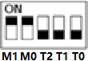 | 11000 | Time Interval is  0 Seconds | At power up, all Relays open
 | 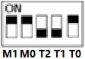 | 11001 | Time Interval is  1 Seconds | Power up,Relay 1 open,  After 1 second Relay 2 open,  After 2 second Relay 3 open…
 | 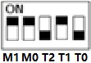 | 11010 | Time Interval is  2 Seconds | Power up,Relay 1 open,  After 2 second Relay 2 open,  After 4 second Relay 3 open…
 | 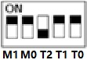 | 11011 | Time Interval is  5 Seconds | Power up,Relay 1 open,  After 5 second Relay 2 open,  After 10 second Relay 3 open…
 | 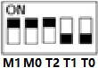 | 11100 | Time Interval is  20 Seconds | Power up,Relay 1 open,  After 20 second Relay 2 open,  After 40 second Relay 3 open…
 | 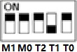 | 11101 | Time Interval is  60 Seconds | Power up,Relay 1 open,  After 60 second Relay 2 open,  After 120 second Relay 3 open…
 | 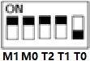 | 11110 | Time Interval is  300 Seconds | Power up,Relay 1 open,  After 300 second Relay 2 open,  After 600 second Relay 3 open…
 | 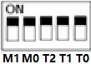 | 11111 | Time Interval is  1200 Seconds | Power up,Relay 1 open,  After 1200 second Relay 2 open,  After 2400 second Relay 3 open…

Wiring diagram:
1 DC 12V(5V/24V) control circuit,Wiring diagram below. "LOAD" may be LED lights, fans, toy car and other DC 12V(5V/24V) equipment
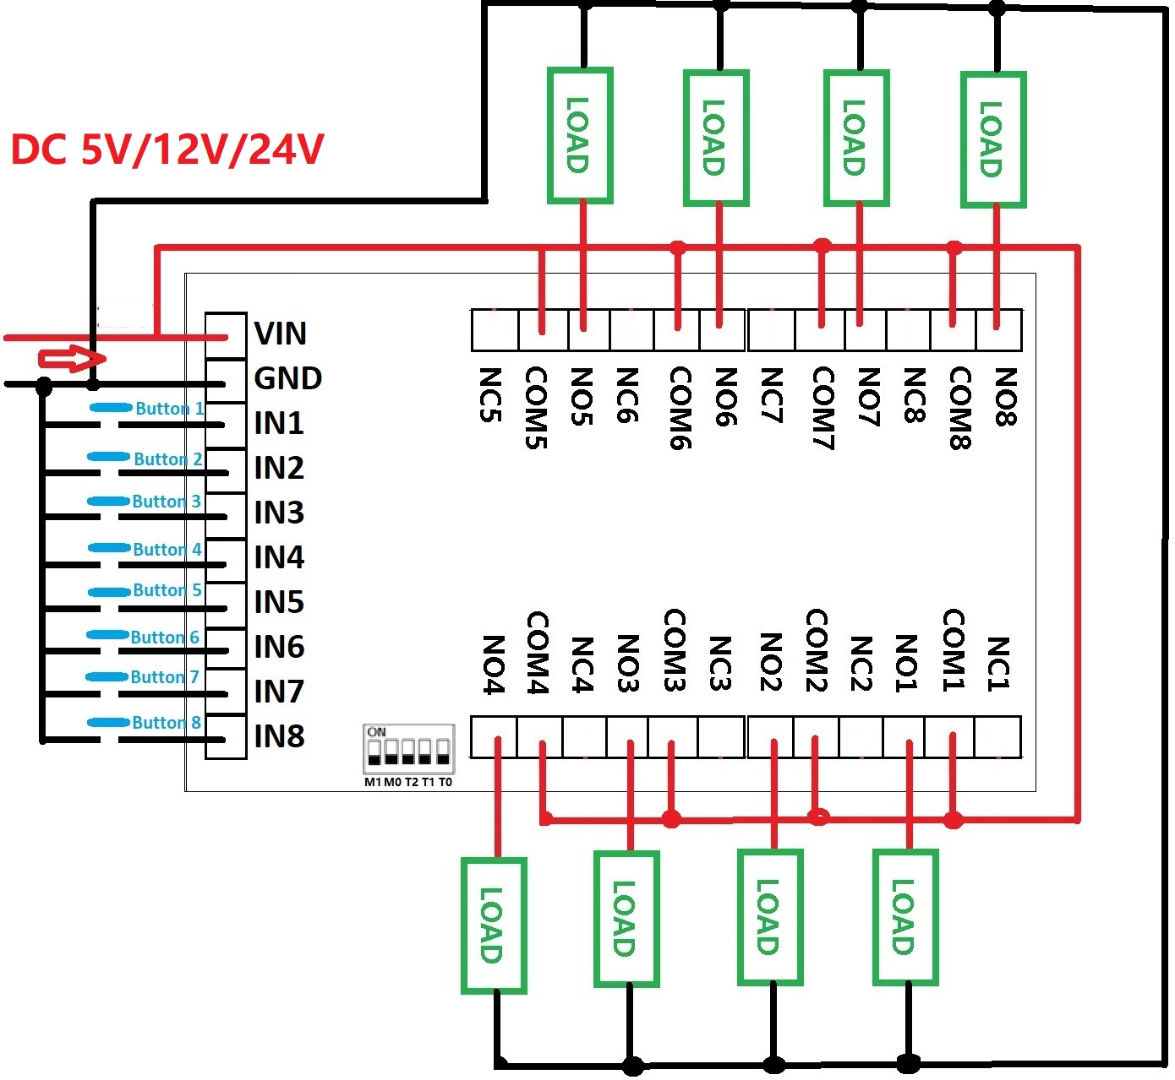

2 DC 1-100V OR AC 85-265V control circuit,Wiring diagram below. "LOAD" may be LED lights, fans, motors and other DC AC equipment
