**IO53A02 2-channels motor forward and reverse controller**

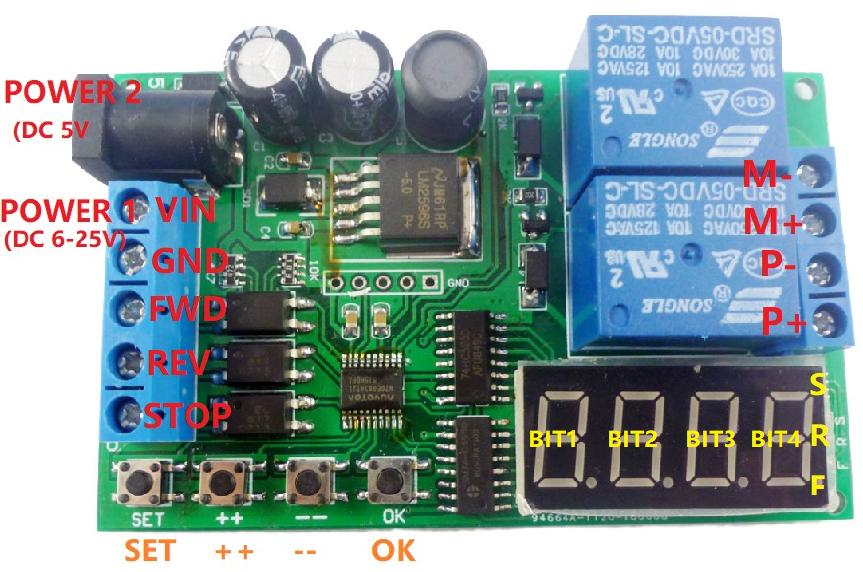

**Product Features:**

1 Dual power supply (two power supplies cannot be powered at the same time):

Power supply 1, DC 6.5-25V; Power supply 2, DC 5V

2 Working current: (Normal Mode) standby current 41mA, working current 83mA;

(Energy-Saving mode) Standby current 7mA, working current 45mA.

3 There are three input control ports: forward control(FWD), reverse control(REV), and stop control(STOP).

4 Two input trigger modes, Low-Pulse trigger mode, Low-Level trigger mode

5 Delay time: 0.1-999.9 seconds, 1-9999 seconds, 1-9999 minutes.

6 Cycle times: no cycle, 2-99 cycles, always cycle.

7 Three indicators: forward indicator(F LED), reverse indicator(R LED), stop indicator(S LED).

8 6 functional modes.

9 Relay load current, recommended less than 5A.

10 Size: 80*50*19mm

11 Weight: about 50 grams

This is a multi-function DC/AC motor forward and reverse controller with multiple control modes. Many control functions can be derived through reasonable settings.

**Port:**

DC 5.5MM female : Power supply 1, DC 5V power supply.

VIN : Power 2 positive, DC 6.5-25V power supply

GND : Power supply 2 negative

FWD : Forward input control (partial Function-Mode is invalid)

REV : Reverse input control (partial Function-Mode is invalid)

STOP : Stop input control (partial Function-Mode is invalid)

M+ : Motor positive

M- : Motor negative

P+ : Positive motor power supply

P- : Negative motor power supply

**Wiring:**

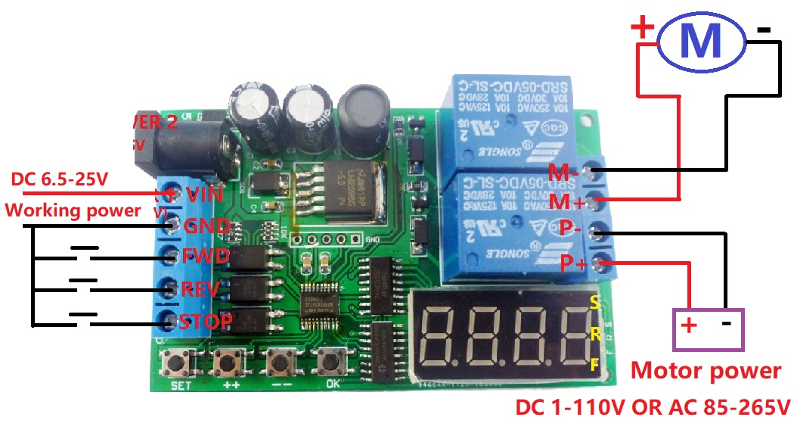

1 The working power supply is 6.5-25VDC. The motor is a DC 1-110V DC motor or AC 85-265V AC motor.

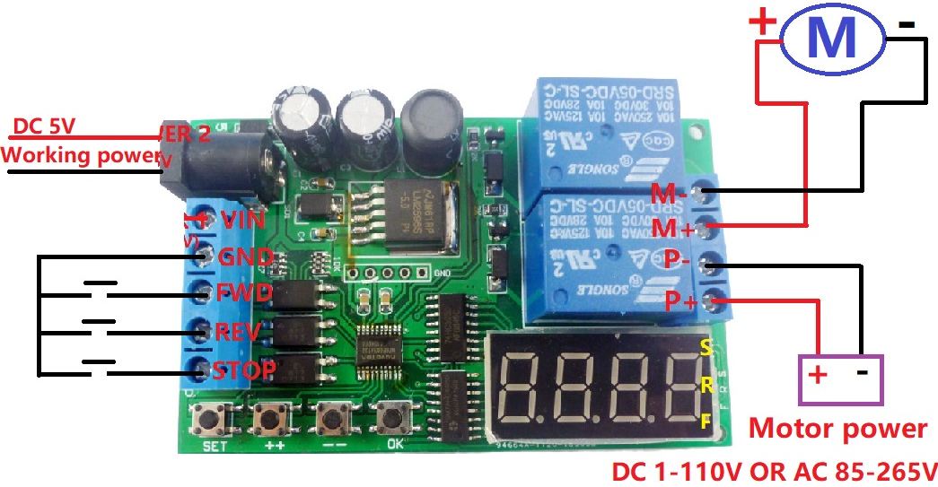

**2 The working power supply is 5VDC. The motor is a DC1-110V DC motor or an AC 85-265V AC motor.**

**Q&A:**

Q1: Why is the digital tube not lit after power-on?

A1: This is because the “Energy-Saving mode” is set, please press and hold the OK button for 5 seconds to exit the energy saving mode.

Q2: Why does the motor not work after the motor is connected to the M+/M- port?

A2: The working power and motor power of the board are independent. You need to supply power to the motor. The power port is P+/P- port. It is recommended to use two separate power supplies for the working power supply and the motor power supply.

Q3: Why is the parameter setting invalid?

A3: After setting the parameters, be sure to re-power,Parameter settings can be saved permanently.

**Trigger mode:**

1 low pulse trigger (falling edge trigger)

2 low level trigger (rising edge trigger)

**Timer:**

T1: Forward timer

T2: Reverse timer

T3: Stop timer

Time unit : 0.1 second, 1 second, 1 minute

**Relay action:**

Motor forward : Relay 1 is ON, relay 2 is OFF, and the F LED indicator is flashing.

Motor reverse : Relay 1 is OFF, relay 2 is ON, and the R LED indicator is flashing..

Motor stop : Relay 1 is OFF, relay 2 is OFF, and the S LED indicator is flashing.

**Factory settings:**

Press the "++" and "--" buttons simultaneously for 5 seconds.

**Energy-saving mode:**

Press and hold the “OK” button for 5 seconds to enter the “Energy-saving mode”. Press and hold the “OK” button again for 5 seconds to exit the “Energy-saving mode”. Energy saving mode just turns off the digital tube and LED indicator, and other functions are normal.

**Function mode:**

F-01

After power-on, the motor is forward T1 time; then the motor stops T3 time; then the motor reverse T2 time; so it is repeated Nx times. When the STOP port is triggered, the motor stops working immediately. (FWD, REV port is invalid)

F-02

This function is a F-01 variant. F-01 is run directly after power-on, but F-02 needs to trigger FWD or REV port to run.

F-11(Trigger reversible 1）

Trigger the FWD port, the motor is forward T1 time, and automatically stops (in order to protect the motor, during the delay period, trigger the REV port to stop T3 time and then reverse T2 time, trigger FWD port to re-time T1).

Trigger the REV port, the motor is reverse T2 time, and automatically stops (in order to protect the motor, during the delay period, the FWD port is triggered to stop the T3 time and then the T1 time is forward, and the REV port is re-timed T2).

When the STOP port is triggered, the motor stops immediately, regardless of whether the motor is forward or reverse.

F-12(Trigger reversible 2）

Trigger the FWD port, the motor is forward T1 time and stops automatically (during the delay period, except for triggering STOP port, the other ports are invalid).

Trigger the REV port, the motor is reverses T2 time, and automatically stops (during the delay period, except for triggering STOP port, the other ports are invalid).

When the STOP port is trigger, the motor stops immediately, regardless of whether the motor is forward or reverse.

F-21

When the FWD port is low level, the motor is forward, and after the FWD port is released, the motor stops.

When the REV port is low level, the motor is reversed, and after the REV port is released, the motor stops.

In this mode, the FWD and REV ports cannot be connected low level at the same time, and the STOP port is invalid.

F-22

When the FWD port is low level, the motor is forward, and after the FWD port is released, the motor stops.

When the REV port is low level, the motor is reversed, and after the REV port is released, the motor stops.

In this mode, the FWD and REV ports cannot be connected low level at the same time, triggering the STOP port, the motor stops immediately.

**Parameter setting:**

There are three menus: Work Menu, Function Menu, Parameter Menu.

Note: When entering the “Function Menu” or “Parameter Menu”, the module still works normally (countdown and the trigger is running normally). The set parameters are valid only after being powered on again.

1 Power on to enter the running state (Work Menu).

If the current function is F-01, then the motor direct run and the digital tube displays the countdown. F-01 is displayed after the operation is completed.

If the current function is other functions, such as F-11. Then the digital tube displays F-11. After the trigger, the digital tube displays the countdown. After the operation is completed, F-11 is displayed.

Description: The forward countdown F LED indicator flashes, the reverse countdown R LED indicator flashes, and the S LED indicator flashes when stopped.

|  |  |  |
| --- | --- | --- |
| Function mode | Digital tube display | Setting method |
| Function 01 | F-01 | Short press the "SET" button to enter the setting state, then use the "++" button and the "--" button to select the corresponding submenu setting, short press the "OK" button to return to the previous menu. |
| Function 02 | F-02 |
| Function 11 | F-11 |
| Function 12 | F-12 |
| Function 21 | F-21 |
| Function 22 | F-22 |

2 In the running state(Work Menu), short press the SET button to enter the “Function Menu” (Above table).

|  |  |  |  |  |
| --- | --- | --- | --- | --- |
| Digital Tube  Bit1  (Parameters) | Bit 2 | Bit 3-4 | Parameter definition | Default parameter |
| 1 | - | 00-99 | Timer T1：single digit and tens digit | 04 |
| 2 | - | 00-99 | Timer T1：hundreds digit and thousands digit | 00 |
| 3 | - | 00-99 | Timer T2：single digit and tens digit | 02 |
| 4 | - | 00-99 | Timer T2：hundreds digit and thousands digit | 00 |
| 5 | - | 00-99 | Timer T3：single digit and tens digit | 01 |
| 6 | - | 00-99 | Timer T3：hundreds digit and thousands digit | 00 |
| 7 | - | 01-03  01 :0.1 seconds  02: second  03:minute | time unit | 02 |
| 8 | - | 0-99 | Number of cycles Nx | 1 |
| 9 | - | 01-02  01 Low pulse trigger  02 low level trigger | Trigger mode | 01 |

3 Press the "SET" button under “Function Menu” to enter the “Parameter Menu”.(Above table)

In the “Parameter Menu”, short press the "SET" button to select the parameters of 1-9, and set the parameters through the "++" button and the "--" button. Short press the "OK" button to save the current settings and return to the previous menu (Function Menu)

Description:

1 Timer T1 T2 T3 time unit is 0.1 sec / sec / min, so the timing range of T1 T2 T3 is 0.1-999.9 seconds, 1-9999 seconds, 1-9999 minutes

2 The number of cycles is the number of repeated actions (Nx =0 means always loop, Nx =1 means no loop). So you can set the number of loops: 1-99 times or forever loops.

3 F-21, F-22 function, Nx=1 parameter can not be changed