**4 channel multi-function wireless controller** 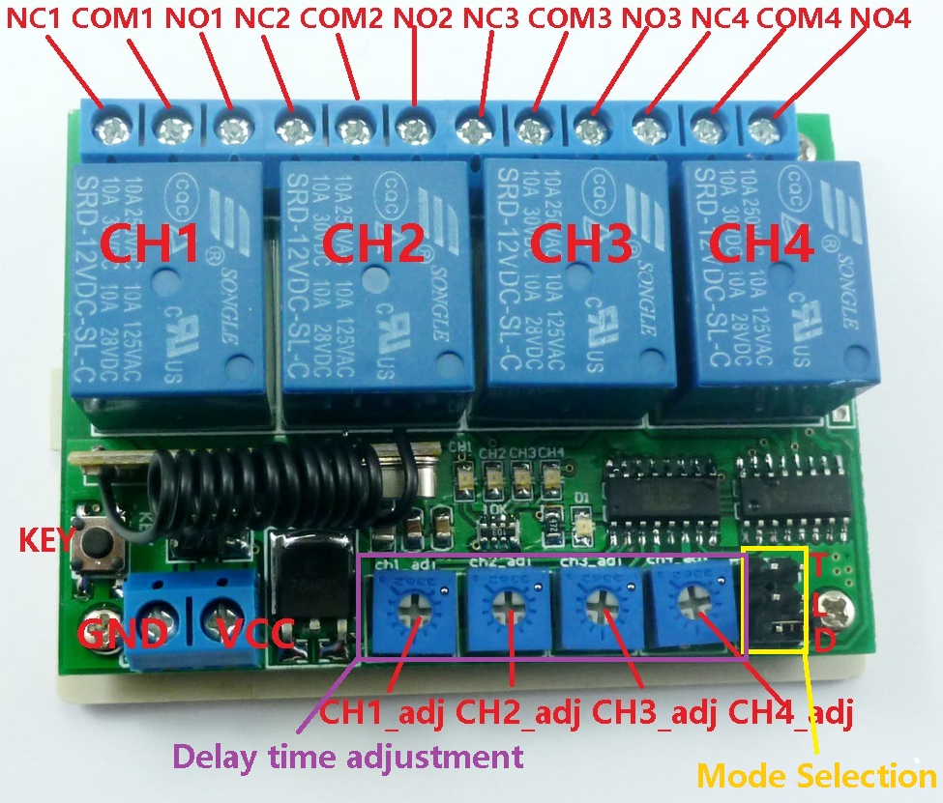

**Features:**

1 Operating voltage: DC 12V

2 Operating Current: Standby current (all relays closed) 15MA, 1 relay open 42MA, 2 relays open 62MA, 3 relays open 94MA, 4 relays open 121MA

3 Operating frequency: 433.92M;

4 Receiver sensitivity : -108dBm

5 Decode : learning code, can be adapted EV1527 / PT2262 and compatible remote control, you can store up to 8 remote control

6 Work mode : Non-locking (Momentary is defult),Self-locking (Toggle),Inter-locking (Latch)， Delay; Delay adjustable from 0.1 to 100 seconds, 0.1 seconds Resolution.

7 Size(Including housing）75*54*28mm

8 Weight: 77g

8 Relay Maximum load(Recommended<5A):10A/250VAC,10A/125VAC,10A/30VDC, 10A/28VDC ,10A/12VDC

**Work mode**

|  |  |
| --- | --- |
| Mode Selection | Work mode |
|  |  |
|  | Momentary /Non-locking  (Mode 0) |
|  | Toggle /Self-locking  (Mode 1) |
|  | Latch /Inter-locking  (Mode 2) |
|  | Delay  (Mode 3) |

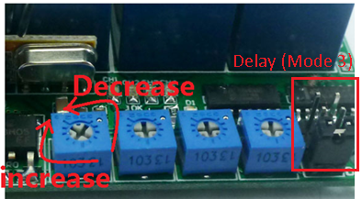

**Delay mode user guide :**

1 In delay mode(Mode 3),with a suitable screwdriver and gently rotating adjustable resistance;Clockwise, increasing delay,Counter-clockwise, the delay is reduced

2 Delay adjustable from 0.1 to 100 seconds, 0.1 seconds Resolution.

**Glossary:**

NO : Relay normally open contact

COM : Relay common contact

NC : Relay normally closed contact

Open : NO connection COM, NC disconnect COM

Close : NO disconnect COM, NC connection COM

Momentary : Press the Transmitter button A, the receiver Channel 1 is Open, release button A; the receiver Channel 1 is Close, the same as B ,Every Channel is Independent ;

Toggle : Press transmitter button A for 1 time , the receiver Channel 1 is Open, press button A again, the receiver Channel 1 is Close, the same as B. Every Channel is Independent ;

Latched : Press transmitter button A, the receiver Channel 1 is Open, the Channel 2 is Close.

Press transmitter button B, the receiver Channel 2 is Open, the Channel 1 is Close.

Delay : Press the Transmitter button A, the receiver Channel 1 is Open,After a set time delay, the receiver Channel 1 is Close, the same as B ,Every Channel is Independent;

If during the delay, press the button of Transmitter, delay start again; if the delay period, press and hold the button of Transmitter 3-4 seconds, the receiver controller stops the delay, the relay Close

**Adapter remote control (learning remote control):**

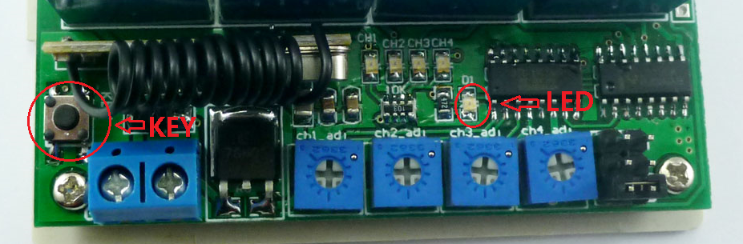

Under normal operating mode, LED will be lit, when receives a valid remote control (EV1527 / PT2262) button values, LED flashes

Clean code: press the button and held down, LED off, LED will light about 8 seconds later, clean code is completed (Note: After performing clean code previously stored remote control value does not exist)

Step 1 (into the learning mode): Press the button (about 1 second), LED off;

Step 2 (adapter channel 1): Then press the first button on the remote control, LED flashes four times off, then learning the first button value

Step 3 (Adaptation Channel 2): Then press the second button on the remote control, LED flashes four times brighter, then learned two key values

Step 4 (Adaptation Channel 3): Then press the third button on the remote control, LED flashes four times brighter, then learned two key values

Step 5 (Adaptation Channel 3): Then press the fourth button on the remote control, LED flashes four times brighter, then learned two key values

**Wiring Diagram:**

1 DC 12V control circuit,Wiring diagram below. "LOAD" may be LED lights, fans, motors and other DC 12V equipment

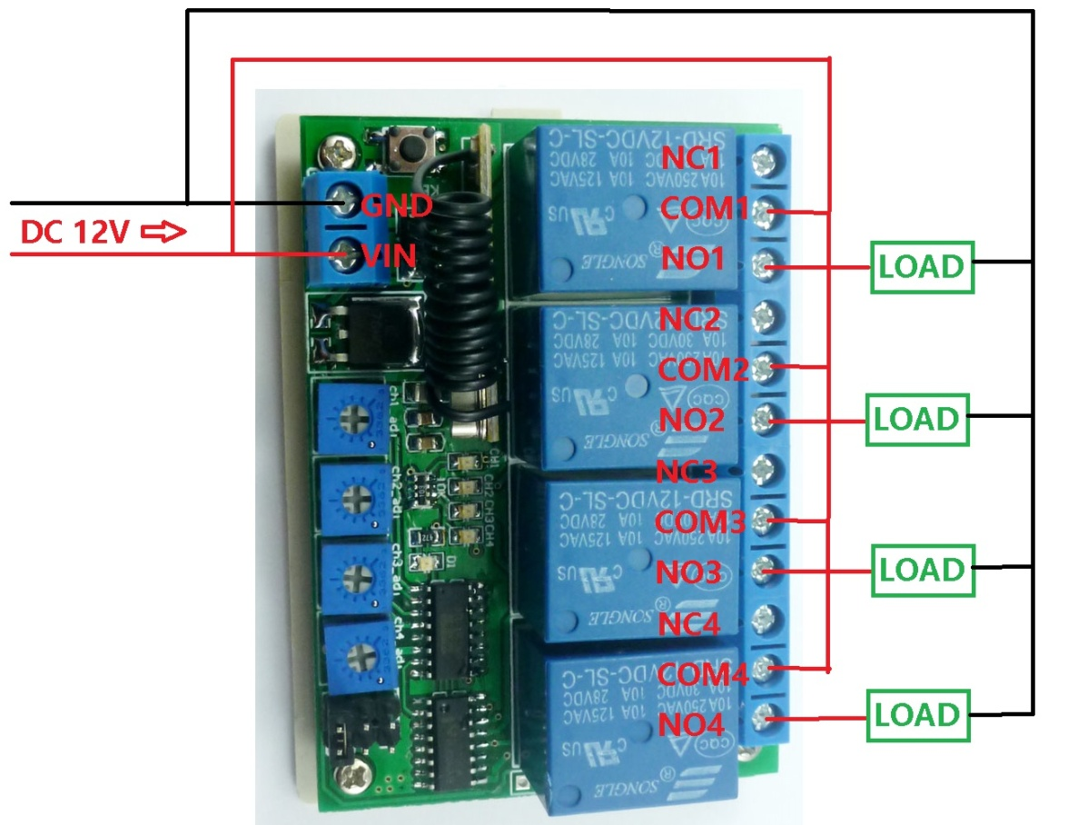

2 DC 1-48V OR AC 85-265V control circuit,Wiring diagram below(Note:If not DC 12V load, need another DC 12V power supply). "LOAD" may be LED lights, fans, motors and other DC AC equipment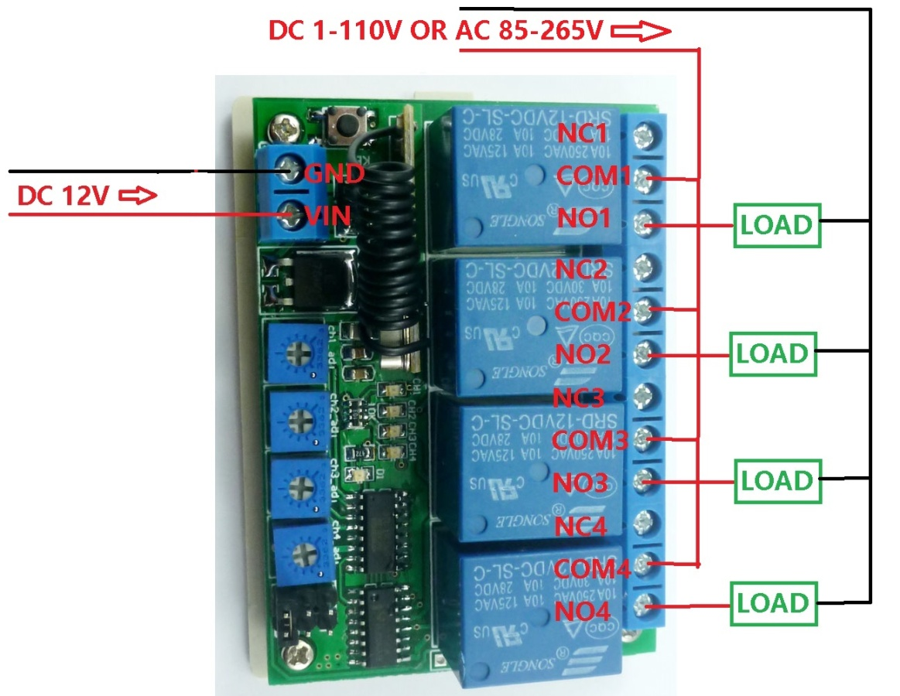

3 All kinds of motor reversing control: DC 1-110V or AC 85-265V DC/AC Motor

