**4-channel multifunction delay relay**

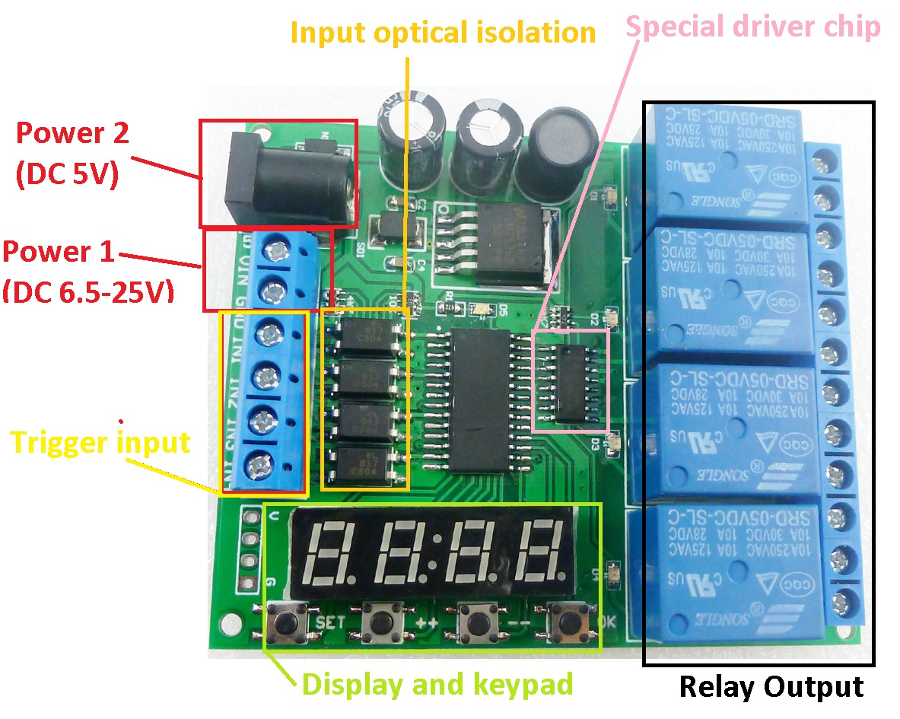

**Product Specifications:**

1 Operating voltage: power supply 1,DC 6.5-25V; power supply 2,DC 5V

2 Operating Current(DC 12V): Standby current (all relays closed) 16MA, 1 relay open 50MA, 2 relays open 82MA, 3 relays open 115MA, 4 relays open 150MA

3 Size: 80x66x20

4 Weight : 75g

5 Relay maximum load capacity: DC 1-100V/6A; AC 85-265V/5A

**Product Features:**

4 channel relay, each channel independently triggered independent delay, do not interfere with each other.

6 kinds of functional modules, each functional module has three sub-modes (no cycle, Maximum 99 cycle, always cycle).

Input optical isolation.

Power anti-reverse diode.

High Q value SMD electrolytic capacitors.

**Short press:** press key time is less than 2 seconds;

**Long press:** press key time more than 2 seconds;

**Status:** working status , set status, power-saving status.

**working status :** start work after powering . Displays the remaining time of 1 channel, the parameters can be displayed the "channel select" to set ;

**Set status:** short press the "SET" key to enter "channel select" Status. Short press "OK" button to exit the setting;

**power-saving status:** in this Status , digital tubes donot display, and other features work correctly. Long press "OK" button after 5 seconds to enter power-saving status, press again "OK" button for 5 seconds or re-power to exit power-saving status.

**Factory settings:** press and hold "++" and "--" two button for 3 seconds, to restore factory settings, and the digital tube will turn open . After re-power , will run default parameters .

**Settings:**

1. After power , the remaining time of digital display channel (default channel 1).

2.Press "SET" button to enter "channel select" interface. In the "channel select" screen, then press "++"/"-" button to select channel to operate (relay). Press "OK" button will exit "channel select" screen, and save the current parameters. Press "SET" button into "parameter settings" interface.

3. under "parameters" screen press "SET" button you can switch parameters. "++"/"-" Button to modify the parameters. Press the "OK" button to exit the "parameters" screen, and save the current parameters.

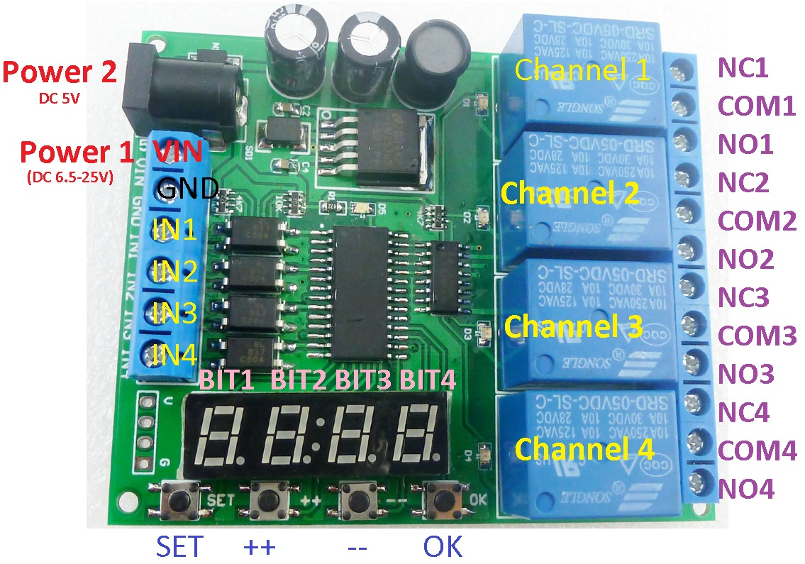

"channel select" interface：

|  |  |  |  |
| --- | --- | --- | --- |
| BIT 4、BIT 3 | BIT 2 | BIT 1 | Instructions |
| Ch | - | 1 | Under this screen press "SET" to Setting Channel 1 Parameters. |
| Ch | - | 2 | Under this screen press "SET" to Setting Channel 2 Parameters. |
| Ch | - | 3 | Under this screen press "SET" to Setting Channel 3 Parameters. |
| Ch | - | 4 | Under this screen press "SET" to Setting Channel 4 Parameters. |

"parameter settings" interface

|  |  |  |  |  |
| --- | --- | --- | --- | --- |
| BIT 4  （Parameters） | BIT 3 | Parameter definition | BIT 2 BIT 1 | Factory default parameters |
| 1 | - | Function Mode（F） | F0-F5 | F0 |
| 2 | - | Timer T1: seconds | 00-59 seconds | 4 |
| 3 | - | Timer T1: minutes | 00-59 minutes | 0 |
| 4 | - | Timer T1: hours | 00-99 hours | 0 |
| 5 | - | Timer T2: seconds | 00-59 seconds | 4 |
| 6 | - | Timer T2: minutes | 00-59 minutes | 0 |
| 7 | - | Timer T2: hours | 00-99 hours | 0 |
| 8 | - | Number of cycles : Nx | 00-99 | 1 |

Timer T1 T2 time minimum unit is second, so the timing range of T1 T2 is 99 hours 59 minutes 59 seconds.

The number of cycles(Nx) is the number of cycles to perform an action triggered once(Nx = 00 indicates always cycle, Nx = 01 means no cycle).So you can set Number of cycles is: 1-99 times or always cycle.

Noun resolved:

NO : Relay normally open contact

COM : Relay common contact

NC : Relay normally closed contact

Relay open: COM connect NO.

Relay close: COM disconnect NO.

**Function Mode：**

The following Function Modes can be set to cycle mode operation.You can set Number of cycles (Nx 1 ~ 99 times, 00 is always cycle, the default is 01 not cycle).

**F0**：After power-up, the relay close. Trigger input (IN1/2/3/4), relay open. T1 time delay close.

**F1**：After power-up, the relay open. Trigger input , relay close. T1 time delay open.

**F2**：After power-up, the relay close. Trigger input , delay time T1 and relay open. T2 time delay relay close.

**F3**：After power-up, the relay open.Trigger input , delay time T1 and relay close. T2 time delay relay open.

**F4**：After power-up, the relay close. After the delay time T1 and relay open. T2 time delay relay close.

**F5**：After power-up, the relay open. After the delay time T1 and relay close. T2 time delay relay open.

**Typical applications:**

1 DC 6-25V control circuit,Wiring diagram below. "LOAD" may be LED lights, fans, motors and

other DC 6-25V equipment

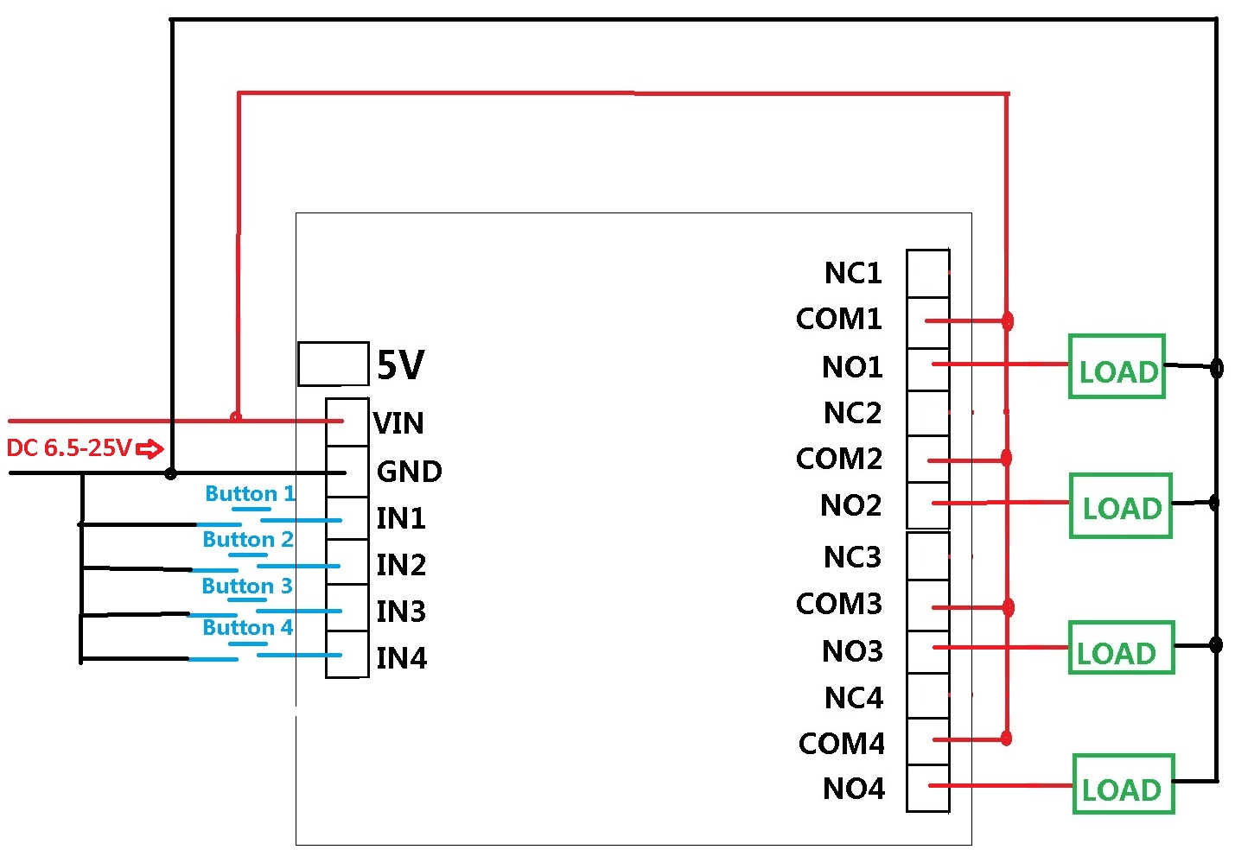

2 DC 5V control circuit,Wiring diagram below. "LOAD" may be LED lights, fans, toy car and

other DC 5V equipment

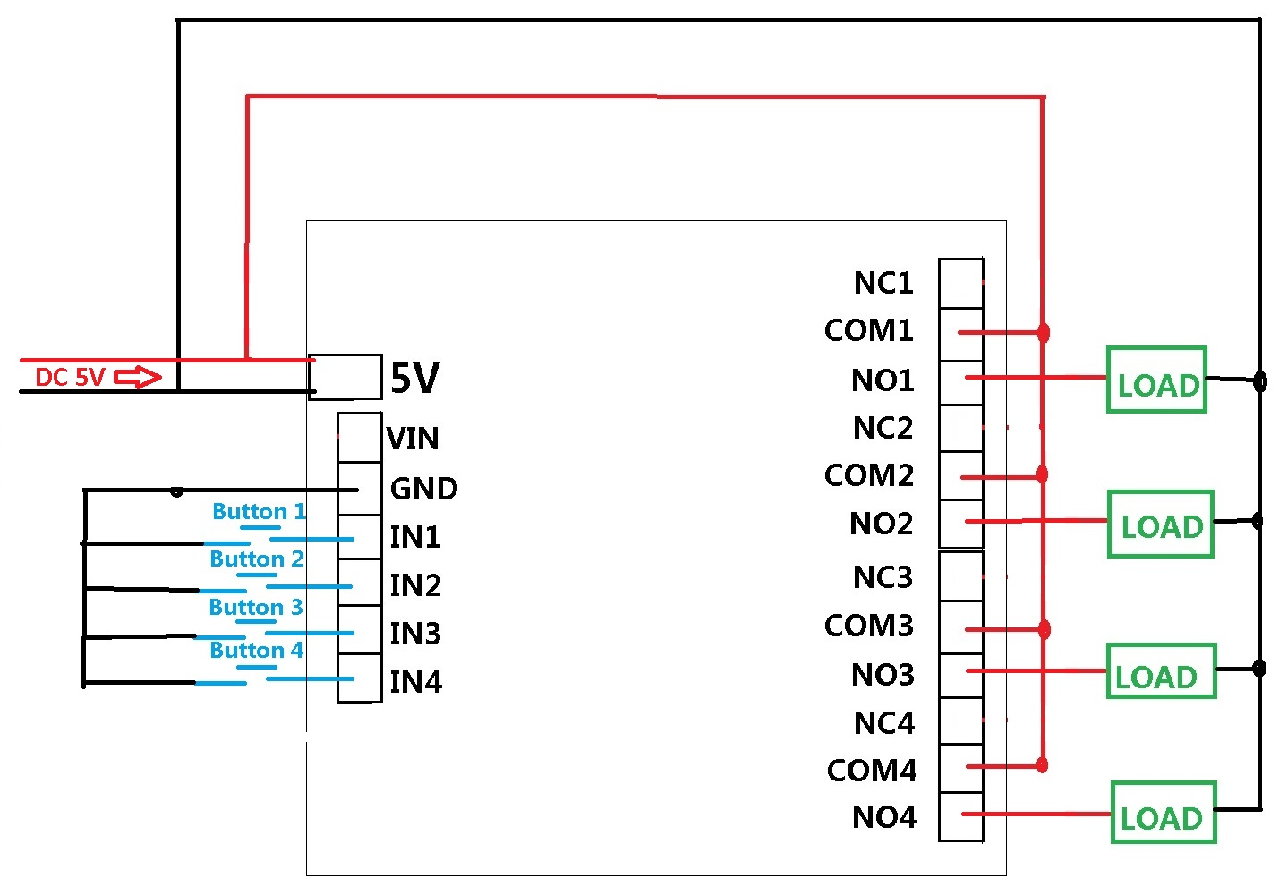

3 DC 1-100V OR AC 85-265V control circuit,Wiring diagram below. "LOAD" may be LED lights, fans, motors and other DC AC equipment

